 | Chapter 4 - Sound Recording and Popular Music

The sound recording industry was the first mass media industry to be upended by digital culture. It is still trying to figure out how to monetize and make its business as profitable as it once was. Downloads have surpassed CDs as the main source of income.

Parents, government and culture have periodically banned popular music because it supposedly corrupts youth.

1840s – Samuel Morse sent electrical impulses over wire from a transmission point to a reception point; the language he used, a series of dots & dashes, became known as Morse Code.

1844 – The first telegraph line was set up between Washington, DC and Baltimore, MD. For the first time in history, communications exceeded the speed on land transportation.

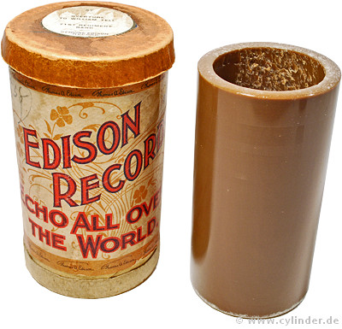 | 1877 – Thomas Edison used tinfoil wrapped around a metal cylinder to record and playback the human voice  ( Mary Had A Little Lamb) on a device called the phonograph. | 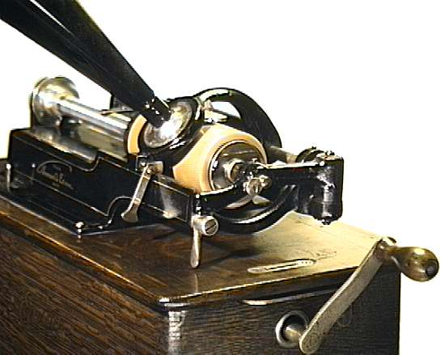

Cylinders of pre-recorded music were problematic:
- difficult to mass-produce
- limited playback durability

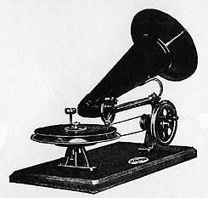 | 1887 – Emile Berliner developed the gramophone, a machine to play flat, recorded metal disks or records. It was a windup machine because electricity wasn’t yet widespread. The disks were easily mass-produced for sale to consumers.  1897: John Phillip Sousa (1854-1932) was arguably the most popular musician of his day. He composed Stars & Stripes Forever, now recognized as the national march, and his band recorded it as a Berliner gramophone.
April 21, 1899: Harry Taft was a popular entertainer whose act consisted of whistling to a piano accompaniment. Notice the low fidelity of this recording, The Mocking Bird. Only one microphone was used.

1906 – This 1906 promotional recording was designed to convince consumers to buy Edison’s Phonograph.

1906 – The Victor Talking Machine Company put the mechanical parts of its turntable inside a piece of wooden furniture to make it more appealing to consumers; the device was called a Victrola (right) and it was hand-cranked.  July 29, 1914: Listen to the lyrics of this Billy Murray recording made on a Victor III phonograph for the Victor Talking Machine label. Note how clean the recording is. | 

1912 – The Titanic struck an iceberg and sank while crossing the North Atlantic. In New York City, wireless telegraph operator David Sarnoff stayed at his key for three days and nights translating messages from rescue ships and compiling a list of survivors.

1916 – Sarnoff wrote, “I have in mind a plan of development which would make radio a household utility in the same sense as the piano or phonograph. The idea is to bring, music into the home by wireless.”

November 2, 1920: Westinghouse Electrical Corporation turned amateur station 8XK into the first commercial radio station, KDKA Pittsburgh. The first scheduled broadcast was coverage of the Cox/Harding presidential election.

[p. 122:] “The first major media convergence involved the relationship between the sound recording and radio industries.”

Wire Recording:
The technology of magnetic recording dates back to 1878, when Oberlin Smith proposed the idea of recording telephone signals onto a length of steel piano wire. Over the next thirty years the technology evolved at a “snail’s pace”; stalled by lack of adequate and cost effective electronic amplification.  By 1930, advances in electronics allowed the first commercially successful wire recorders to be introduced as dictating machines and telephone recorders in Europe and North America. During WWII, the machines were used for sending messages from the British to the French underground. From 1947 to 1952 wire recorders became popular in America and Europe, showing up in many homes.  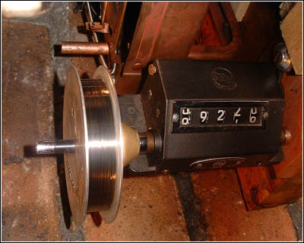 | 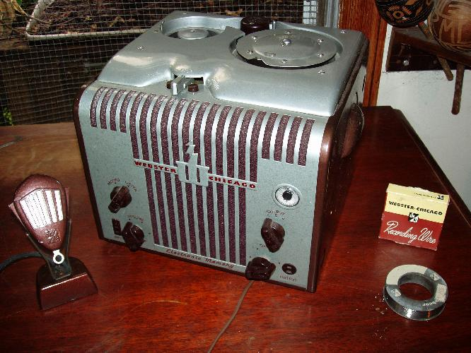
wire recording technology

1920s-1940s – Audio recordings, or records, were made on a variety of disc surfaces including shellac on metal, plastic and glass. They tended to wear out the more they were played.

1940s – Vinyl recordings became state-of-the-art; they were less noisy.

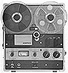 | Late 1940s – Allied forces discovered the Germans had perfected recording on high-speed plastic tapes. The technology was returned to the U.S. and the era of tape recording began. Eventually tape allowed programming to be pre-recorded instead of live. Here is an example of how a live commercial used to sound.  left: Ampex reel-to-reel tape recorder

1948 – CBS Records introduced 33 1/3 rpm long-playing records

1949 – RCA introduced 45 rpm discs; not compatible with CBS system  1953 – CBS & RCA manufactured record players to accommodate both speeds  Cassettes arrived in the mid-1960s.  So did eight-track tapes (right), developed by William P. Lear. Each tape had four stereo programs that ran in parallel on eight tracks for the entire length of a single, continuous tape loop. | 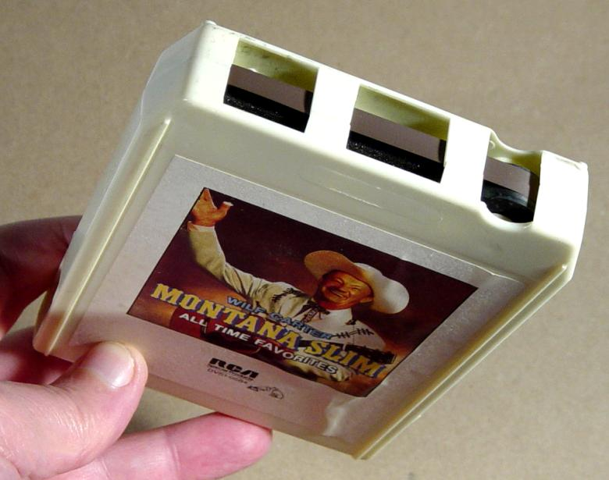
1983 – digitally recorded compact discs (CDs) debuted

1992 – MP3 file format allowed digital recordings to be compressed into smaller files  1999 – Napster allowed people to download and share music files illegally; it was the beginning of revolutionary changes to the music distribution industry  2003 – Apple iTunes was born | 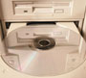

Additional sources:

Victrola Webbucket

Old Time Victrola Music

Vintage Audio Recording History

