 | Chapter 8/Newspapers: The Rise and  Decline of Modern Journalism

Today – the newspaper industry is losing papers & readers in digital age; many investors feel there is little future for print papers
- for years TV & Cable have delivered news more cheaply than papers
- circulation dropped 25% during the first decade of the 2000s
- newspapers were overwhelmed by changes that collided with the 2008-2009 recession
- new generations have grown up without papers (less than 30% use by 18-35s)
- newspapers lost classified ads to free web sites like Craigslist & eBay
- fewer advertisers = less revenue = layoffs & cutbacks = bankruptcy

Way Back Then – earliest news passed orally (family to family, tribe to tribe, by community leaders & oral historians)

15th Century – development of printing press accelerates a society’s ability to send & receive information (novelty/entrepreneurial stages of media development happen in Europe)

Sept. 25, 1690 – first North American newspaper – Public Occurrences – published in Boston

Early Colonial papers not very timely because European news took a long time to travel by ship, so publishers wrote about local illnesses, public floggings, suicides; most papers operated on subsidies from political parties

1734 – John Peter Zenger (New York Weekly Journal) arrested for libel; eventually wins case establishing the precedent that allowed journalists to criticize public officials

Partisan Press – political newspapers that pushed the plan of a particular political group that subsidized the paper; legacy=editorial pages

Commercial Press – served business leaders who were interested in economic issues; legacy=business sections

Readership primarily confined to educated or wealthy men who controlled local politics & commerce; average newspaper cost six cents (yearly $10-12 – a week’s salary)
Penny Papers – appealed to less educated masses and were sold on street rather than by subscription; favored human interest stories that focused on daily trials & triumphs of ordinary individuals facing extraordinary challenges

By gradually separating daily front-page reporting from overt political viewpoints on an editorial page, penny papers shifted their economic base to the market (ad revenue, classifieds, street sales)

Wire Services – commercial organizations that relayed news stories and information around the country and world via telegraph, later radio, today digitally (Associated Press first in 1848); allowed for rapid transmission and paved the way from an entrepreneurial stage to newspapers as a mass medium (marketing news as a product)

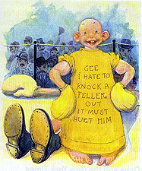 | Yellow Journalism – emphasized profitable papers that carried exciting, human-interest stories, scandal, intrigue, crime news, large headlines and more readable copy… generally regarded as sensationalistic… forerunner of tabloids, reality TV and infotainment shows like Access Hollywood and Entertainment Tonight  Yellow Journalism takes its name from the 1890s circulation war between two New York papers that highlighted a comic strip called the Yellow Kid

Yellow Journalism also responsible for investigative journalism – news reports that hunted out and exposed corruption, especially in business & government

During late 1800s two other types of journalism emerged:
- Story-driven model - dramatizing important events (penny papers & yellow press)
- Just-the-facts model - packaging information impartially (six cent papers)

1896 – Adolph Ochs buys the New York Times and builds substantial news coverage and provocative editorial pages, downplaying sensational stories and documenting major events & issues

Objective Journalism – distinguishes factual reports from opinion columns; reporters have neutral attitude toward stories they cover & seek competing points of view

Inverted Pyramid – story form for packaging & presenting news where the most important info (five W’s) appear at top of story and less important details follow

Objectivity impossible to achieve but still the guiding ideal of the modern press

Interpretive Journalism – explains key issues or events within a broader historical or social context

1930s – battle between print and radio journalists begins; mainstream papers try to copyright facts

Literary Journalism – emerges in 1930s/1940s; it adapted fictional techniques (descriptive details, extensive character dialogue) to nonfiction material and in-depth reporting

Advocacy Journalism – reporter actively promotes a particular cause or viewpoint

Precision Journalism – attempts to make news more scientifically accurate by citing polls & questionnaires

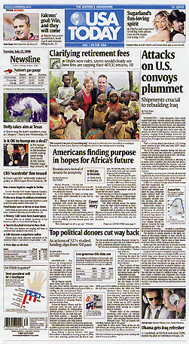 | 1982 – USA Today debuted modeled on TV; characterized by an emphasis on visual style over substantive news or analysis; brief news items appeal to short attention spans  Major dailies consist of one-half to two-thirds advertisements; the newshole is space not taken by ads (remaining 35-50% of content)  [p.290] “Today, online journalism is completely changing the industry.” Instead of subscribing to newspapers, many people check Internet newspaper websites, get news from cable, magazines, bloggers or online-only news organizations.  “…online news has sped up the news cycle to a constant stream of information and has challenged traditional news services to keep up.”

Consensus-Oriented Journalism – articles on local schools, social events, town government; practiced by non-daily papers

Conflict-Oriented Journalism – front-page events, issues or experiences that deviate from social norms; practiced by national & metro dailies; reporters see themselves as observers who monitor institutions & problems

Underground Press – alternative papers that questioned mainstream politics and conventional values, often voicing radical opinions; began in mid 1960s

Feature Syndicate – commercial outlet that provides papers with political writers, editorial cartoonists, comic strips and specialized columns for a fee

Newspaper chains – began in 1890s; by 1920s about 30 chains (each owning 5 papers) controlled the industry – oligopolies

Impact of media convergence
- newspaper industry was slow to comprehend the challenges of the Internet
- many papers gave away news for free online as an advertisement for the print edition
- print reporters now expected to file online versions of stories first; may carry digital cameras to record images or video
- reporters & editors now expected to develop stories in multiple formats with fewer personnel
- many large media empires are more interested in profits than journalism
- after salaries, newsprint is typically the largest expense in the newspaper industry (25%)
- some papers institute paywalls by charging a fee to read online content

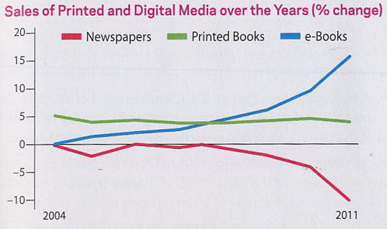

Citizen Journalism – grassroots movement to address cutbacks in traditional newspaper industry; amateurs and concerned citizens use the Internet and blogs to disseminate information

[p.308] “Of all mass media, newspapers have played the longest and strongest role in sustaining democracy.”

