 | Chapter 10/Books and the Power of Print

[p.350] “Books are still the main repository of history and everyday experience, passing along stories, knowledge, and wisdom from generation to generation.”

Books – the oldest mass medium and still the most influential; books survive because they originate some of the biggest ideas and stories that resonate through the rest of the mass media.

Book industry has survived numerous social & cultural challenges…despite convergence with other media

Before writing, people passed on information & values through the memories of community elders or tribal storytellers

5000 years ago – Babylonians and Egyptians experiment with alphabets – pictorial symbols & letters drawn on wood or pressed into clay tablets

2400 B.C. – Egyptians write on papyrus (derivation of the word paper) made from plant reeds; these were rolled up in scrolls

1000 B.C. – Chinese use strips of bamboo & wood tied in bundles to create book-like objects; around time of Christ Chinese begin making paper from cotton & linen

Europeans use parchment, which was made from treated animal skins; stronger, smoother, more durable and less expensive (not imported from Egypt).

3rd century - Chinese perfect the technique of block printing in which sheets of paper were applied to blocks of inked wood with raised surfaces depicting hand-carved letters & illustrations; allowed multiple copies to be printed.

4th century – Romans produce the first protomodern book - the codex - made of sheets of parchment sewn together along the edge, then bound with thin pieces of wood & covered with leather; codex allowed for writing on both sides of page

1000 A.D. – Chinese develop movable type featuring individual characters made from reusable pieces of wood or metal; replaces entire hand-carved pages.

manuscript culture –period during which books were lettered, decorated and bound by hand

Scribes – early priests & monks who transcribed (by hand) most of the existing religious & philosophical texts which survive today; scribes developed rules for punctuation, upper & lower case letters, spacing between words; they also became the first editors for content (censors)

OLDERROMANWRITINGLOOKEDLIKETHISWITHNOSPACEBETWEENWORDS.

Illuminated manuscripts – books with colorful designs and hand-drawn illustrations usually produced for churches or wealthy people

1453-56 – Johannes Gutenberg develops the mechanical printing press in Germany to produce the first modern books; printed on fine calfskin-based parchment called vellum.

[pp.350-51] “…when people could learn for themselves by using maps, dictionaries, Bibles, and the writings of others, they could differentiate themselves as individuals; their social identities were no longer solely dependent on what their leaders told them or on the habits of their families, communities or social class. The technology of printing presses permitted information and knowledge to spread outside local jurisdictions. Gradually, individuals had access to ideas far beyond their isolated experiences, and this permitted them to challenge the traditional wisdom and customs of their tribes and leaders.” – historian Elizabeth Eisenstein

1744 – Benjamin Franklin imports and reprints two European books targeting the newly emerging & literate female middle class

1830s – first paperback books made by machine; cheaper paper covers than hardcover books, make books more accessible to the masses; also called dime novels

1870s – professional & educated classes criticized cheap westerns and crime novels aimed at middle and working-class citizens as having the potential to “ruin civilization”

1885 – one-third of books in America were paperbacks & dime novels; pulp fiction – a reference to cheap, machine-made pulp paper used in printing

1880s – linotype machines – enable printers to save time by setting type mechanically; steam-powered presses permit more production at lower cost

early 1900s – offset lithography – allows books to be printed from photographic plates rather than metal casts; greatly reduces cost of color & illustration

1880-1920 – shift of social life from rural to urban lends to cultural shift; demand for printed media grows especially among European immigrants

1920s-1950s – book popularity waned due to World Wars and Great Depression; radio soared…magazines fared better than books because they were cheaper

[p.354] Figure 9:1 - Estimated U.S. book revenue, 2009

Types of books:
- Trade – for general readers, sold at commercial outlets (adult trade, juvenile trade, comics, graphic novels)
- Professional – aimed at specific occupational groups, not intended for general consumers; sold mainly through mail order, sales reps or Internet
- Textbooks – elementary through high school (el-hi), college, vocational; about half the states mandate which e-hi books must be used & this creates huge buying power…college texts purchased by students rather than school districts
[p.355] Figure 9.2: Where the New Textbook Dollar Goes
- Mass Market Paperbacks – sold in drugstores, supermarkets & airports; usually contemporary works by blockbuster authors; largest segment of book industry, average price under $10
- Religious – best selling book of all time is the Bible
- Reference – dictionaries, encyclopedia, atlases, almanacs; since the 1990s these have struggled with moving to online formats while retaining profitability
- University Press – smallest market, nonprofit, scholarly works for small groups of readers; routinely lose money and are subsidized by university

Comic Books – also called graphic novels:
- gave American culture the Superhero
- debuted in U.S. in 1930s
- by the 1950s critics claimed they caused juvenile delinquency
- in 1954 the industry adopted a restrictive rating code to fend off government regulation
- still stigmatized today as the lowest of low culture

Convergence – two major facets in relationships between books/TV/film:
- How can TV help sell books
- How books serve as ideas for TV shows & movies (resulting in huge movie rights revenues for book industry & authors)

Audio books (talking books) - convergence with audio industry; usually celebrities or authors read abridged versions of their work

E-books – digital books accessed on Internet and read on a computer...the fastest growing segment of the book industry

2007 – Amazon debuts The Kindle, a lightweight, thin reader with an easy-on-the-eye paper display; Kindle uses a wireless connection to choose and download from 120,000 titles. Downloads take less than a minute and device holds 200+ books.

2009 – Kindle 2 released along with other competitors (apps for iPod Touch, iPhone & other smartphones…Nook & Kobo from Barnes & Noble)

2010 – Apple releases iPad, a color touch-screen tablet that quickly outsold Kindle

2010 – Google eBooks debut in a cloud-based format (accessible on any device)

Preservation – older books published on acid-based paper are falling apart; book industry did nothing until 1990s and now uses acid-free paper

Google’s Book Library Project:
- 2004 – the project launched, scanning millions of books and making them available online
- 2008 – dispute over digitizing copyrighted material without permission resulted in agreement that allowed Google, authors & publishers to share the revenue
- 2011 – a federal court struck down the agreement because it gave Google too much power to profit from books for which it didn’t obtain copyright permission

Censorship – like other forms of media, critics occasionally charge that books lower cultural values and pander to the lowest common denominator. Rulers try to ban books to preserve authority and to prevent people from learning about other moral standards. Political censors try to ban books that challenge tradition or express radical ideas.

Book publishing:
Acquistions editor – seeks authors to sign; handles subsidiary rights for author (rights to use book in other media)

Developmental editor – provides feedback to author, suggests improvements

Copy editor – attends to specific issues like writing, length, production

Design manager - decisions about type style, paper, cover design, layout

E-publishing – allows authors to sidestep traditional publishers

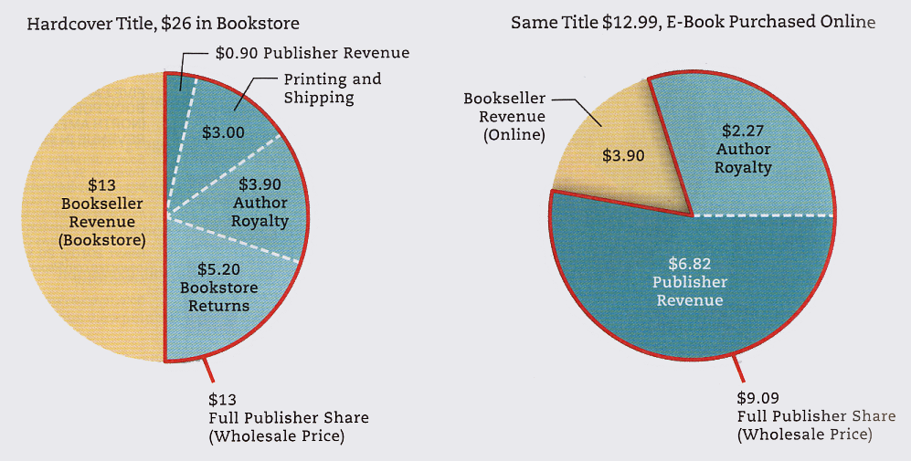
Figure 10.4

Ownership patterns – the book industry oligopoly means a handful of international media conglomerates control the commercial publishing industry; chain superstores put small indies out of business

Bookstores:
- 1991 – bookstores had a 31% share of the market (5100 stores)
- 2010 – bookstores had an 4.3% share of the market (1900 stores)
- sales are dominated by just one chain: Barnes & Noble

Online book sales:
- Amazon.com began in 1995 – controls 60% of e-book market
- convenience
- low price
- larger selection than brick & mortar stores can stock

Amazon is becoming vertically integrated because it signs authors to contracts, it has its own distribution system, and it has sold millions of Kindles. As a result critics say Amazon is too powerful.

e-publishing:
- allows authors to sidestep traditional publishers
- keeps distribution costs low
- provides greater profit

