 | Chapter 12 – Public Relations and Framing the Message

What’s the Difference?
- Advertising - controlled publicity that a company or individual buys; uses simple & fixed messages transmitted directly to public through the purchase of ads
- Public relations – attempts to secure favorable media publicity to promote a company or client; the total communication strategy conducted by a person, government or organization trying to reach & persuade an audience to adopt a point of view. Complex messages evolve over time and may be transmitted to the public indirectly, often through the news media

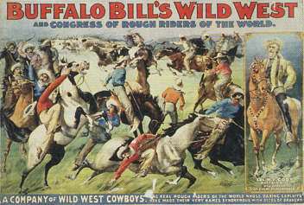  “A Company of Wild West Cowboys. The Real Rough Riders of the world whose daring exploits have made their very names synonymous with deeds of bravery.” (1899 poster) | Press agents – those who sought to advance a client’s image through media exposure, primarily via stunts staged for newspapers  Publicity – a type of PR communications that uses various media messages to spread information about a person, occupation, corporation, issue or policy

Pioneers in shaping the interpretation of facts:
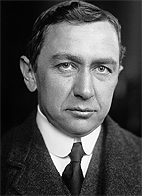  Ivy Ledbetter Lee    Edward Bernays | Ivy Ledbetter Lee – a founding father of PR in the early 1900s… he realized companies could sell more products if they were associated with positive public images & values.  Lee understood the attitude toward big corporations had changed…he believed honesty & directness were smarter than deceptive business practices typical in the late 1800s.  Edward Bernays – the first to apply psychology & sociology to PR. Calling himself a “public relations counselor” rather than a “publicity agent.”  Bernays felt experts & leaders should control the direction of American society.
[p.426] “For the cultural elite to maintain order and control, they would have to win the consent of the larger public. As a result he [Bernays] termed the shaping of public opinion through PR as ‘the engineering of consent’.” – Edward Bernays  Public Relations Society of America (PRSA) –  “PR helps an organization and its publics adapt mutually to each other”  Propaganda – communication strategically placed, either as advertising or publicity, to gain public support for a special issue, program or policy |  | 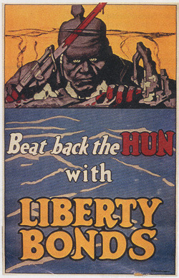  WW I poster  created by Bernays

PR tasks include:
- Writing press releases  - Managing media requests  - Staging special events  - Dealing with internal/external publics  - Research | - Formulating a message  - Conveying the message  - Sustaining public support  - Maintaining client interests

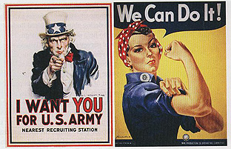  World War II propaganda campaign | Pseudo-event – circumstance created for the sole purpose of gaining media coverage  Press releases – announcements written in the style of news reports that provide information about an individual or company to the news media

Video News Release (VNR) – 30-to-90-second visual press releases designed to mimic the style of a broadcast news report; in 2005 FCC ruled stations must disclose the nature source and sponsorship

Public Service Announcement (PSA) – audio or video spot promoting government programs, educational projects, social reform or not-for-profit organizations

The Internet is an essential avenue for transmitting PR messages. It is used for uploading press releases, press kits, VNRs, web images, and social media & other sites featuring user-generated content.

Media Relations – paid employees who specialize in securing publicity or favorable coverage in the news media for an organization or client. In industries that deal frequently with government agencies, this type of specialist works in government relations. Either way, these specialists do damage control, or crisis management, when publicity is negative (think BP and the Gulf oil spill)

Lobbying – the process of attempting to influence lawmakers to support & vote for an organization or industry’s best interests

Astroturf lobbying – phony grassroots campaigns engineered by PR firms to create the impression that millions of people back their client’s side of an issue

Impact of Internet on Public Relations:
- Internet provides new routes of instant accessibility, bypassing media coverage
- Company web sites are ground zero for PR because they present a narrative precisely the way they wish the message to get out
- Media kits are accessible online…for the media & general public
- Fewer barriers between organizations and their internal/external publics
- Social media enables PR practitioners to interact directly with publics

Dangers of Internet PR:
- Some communications lack full disclosure
- Some companies compensate bloggers to promote their products (in 2009 the FTC enacted rules requiring full disclosure)

Social Media:
- American public turns to the Internet for news
- Journalists are becoming more comfortable with online research, e-mail interviews, and embedded media in stories
- Dominic Jones: “The single purpose of news releases today should be to get people to link to the details on our websites.” [p.432]

Flack – derogatory term used by media to describe PR agents who insert themselves between their clients & the press

Why journalists dislike PR flacks:
- Blocks access to important officials
- Agents promote that which traditionally would be bought as advertising
- Bigger agencies secure disproportionate amount of coverage for clients

Spin – a conscious emphasis on, or downplaying of, certain facts to present a more favorable story

Problems when the press relies on public relations:
- If PR can secure news publicity, the added credibility of journalistic context gives clients a status that the purchase of advertising cannot offer.
- PR firms with abundant resources clearly get more client coverage from the news media than their lesser-known counterparts.
- Because PR professionals work so closely with the press, their practices are not often the subject of media reports or investigations.
- PR professionals police their own ranks for unethical or irresponsible practices, but the news media should also monitor the PR industry as it does government and business activities.
- PR is criticized for the crush of information it produces; that crush has overwhelmed traditional journalism

[p.441] “Modern public relations redefined and complicated the notion of what ‘facts’ are. PR professionals demonstrated that the facts can be spun in a variety of ways, depending on what information is emphasized and what is downplayed.”

