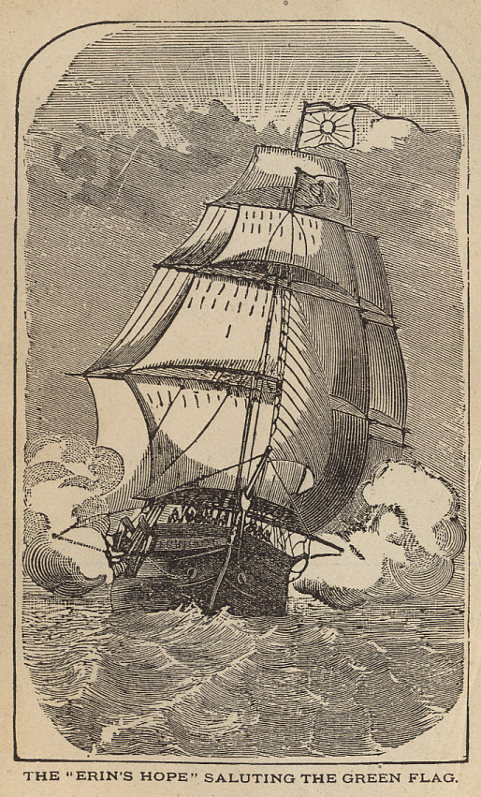
From “The Manchester Tragedy: The Cruise of the Jackmel”

Speeches From The Dock or Protests of Irish Patriotism
Second American Edition
Henry McElroy
Murphy and McCarthy, Providence, R.I.
1879

