DGME240/DIGITAL AUDIO PRODUCTION – Final Exam – August 21, 2014

Your name:

 | 1. (4 pts) Explain exactly what you are looking at in the image to the left.  Meter
2. (4 pts) What are the four stages of the multitrack recording process?
A.
B.
C.
D.

3. (4 pts) Some producers prefer to work in Adobe Audition’s Mixer View rather than the Multitrack Editor. What is the one downside of the Mixer View?

4. (4 pts) Which of the following appears as a red bracket (]) in Adobe Audition?
- snap button
- ripple delete
- pan control
- trim tool
- global clip stretching

5. (4 pts) To the right is the pickup pattern of a common type of microphone. Identify it and explain the most likely setting for its use. | 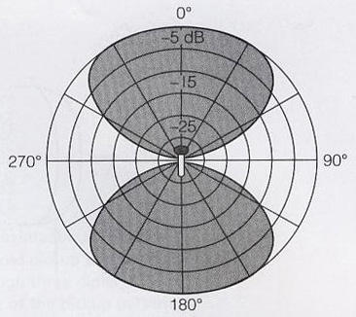

6. (4 pts) Explain what a metronome is and how it would be used in digital audio production?

7. (3 pts) TRUE OR FALSE: The more tracks you add to a multitrack production, the softer the overall volume.

8. (3 pts) FILL IN THE BLANK: An Adobe Audition function called _______________ records control changes you make while mixing, including track parameters and effects.

9. (4 pts) When creating a multitrack production, why is it best to start with all tracks centered in the stereo field?
10. (3 pts) TRUE OR FALSE: Adobe Audition is a video editor that can create a separate video preview track at the top of the workspace.

11. (4 pts) What is the difference between an Adobe Audition file with a “.PK” extension versus one with an “.SESX” extension?

12. (4 pts) Explain the concept of a mixing bus.

13. (4 pts) Describe what you see in the image to the right. | 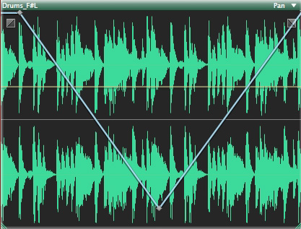

14. (3 pts) TRUE OR FALSE: In the Mixer View some parts of the Mixer can be hidden.

15. (7 pts) Identify the seven functions depicted on this toolbar from left to right.

16. (3 pts) FILL IN THE BLANK. Two pieces of music playing simultaneously is called ______________________.

17. (4 pts) What is the difference between royalty-free music and needledrop music?

18. (4 pts) Within the Adobe Audition software, where would you find the image depicted on the right? What is it showing and how can you tell? | 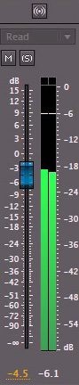

19. (4 pts) What is a composite recording?

20. (4 pts) Explain the difference between clip automation and track automation.

21. (4 pts) Explain what you see in this screen shot.
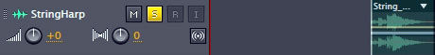

22. (3 pts) TRUE OR FALSE: Since walls, floors, ceilings and windows don’t interact with speakers, it doesn’t matter whether the speakers are placed symmetrically within a room.

23. (4 pts) A reference tool used to create places in a video where there are important transitions or events is called:
A. keyframe
B. hit point
C. marker
D. speech volume leveler
E. envelope
F. noise print

24. (3 pts) FILL IN THE BLANK: When studio musicians sing along with the lead vocal to create harmonies or a thicker sound they are doing what is known as _______________.

25. (4 pts) What is ADR?

26. (4 pts) As specifically as possible describe what this image depicts.
