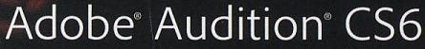  CLASSROOM IN A BOOK® | Chapter 5  Audio Restoration

Audio restoration involves tradeoffs. The “law of unintended consequences” means that if you alter a file in one way it might have an unexpected or undesirable impact in another way.

1. Hiss reduction
Hiss – a natural by-product of electronic circuits. Adobe Audition has two tools:
- Hiss reduction – may reduce high frequencies
- Noise reduction – use the minimum amount to avoid altering the rest of the file

Noise floor – a portion of an audio file that contains only noise

Noise print – functions like an audio fingerprint by sampling the noise floor and removing any remaining audio with those characteristics from a file

2. Click reduction – crackles and clicks usually result from scratchy vinyl recordings, or a bad audio connection

The Threshold Slider is used to set the sensitivity to clicks…lower values will “trap” more clicks but may also reduce lower-level transients you want to keep

Complexity is the tool for setting how much processing Audition will perform…higher settings recognize more complex clicks but makes the CPU work harder and may degrade overall audio

There isn’t a lot of noticeable difference between minor complexity setting variations.

3. Noise reduction – use to reduce hum, air conditioning & ventilation sound, and hiss

The offending sounds must be relatively constant for this process to work

There must be an isolated section of background noise to capture a noise print

4. Removing Artifacts – [Ch. 3:] “any unwanted remnant of sound that remains after an edit”
Audition uses the Spectral Frequency Display (below) to edit based on amplitude, time and frequency

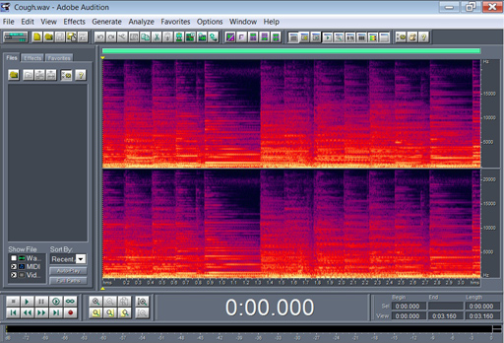

Spectral Frequency Display of the Cough.wav file

5. Alternate click removal – Spectral Frequency Display can also be used to remove clicks

Since it is a manual process it is more time consuming

It can result in more accurate edits with less impact on overall audio

6. Healing – replaces audio with cross-faded, “good” audio from either side of an artifact.

