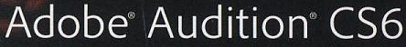  CLASSROOM IN A BOOK® | Chapter 9  Multitrack Editor Orientation

Multitrack production – assembles multiple audio tracks to create a {musical} composition…there are four stages in the production process:

- Tracking – involves recording or importing tracks into a Multitrack Session

- Overdubbing – recording additional tracks

- Editing – polishing the individual tracks

- Mixing – where tracks are blended together into a final stereo or surround file…this stage involves adjusting levels and adding effects

The Multitrack Editor allows multiple versions of the same track to be displayed in a waveform. However, only one copy of the track is stored in RAM (Random Access Memory). The same clip simply plays multiple times as indicated in the waveform.

TRACK CONTROLS:
Each track has multiple controls arranged in two sections, which primarily affect playback.
- One section has a set of fixed controls.
- The other section is an area whose controls change according to a particular selected function.

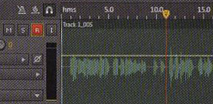  armed track (red button) | 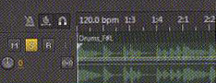  solo track (yellow button)

Main Track Controls:
- the most commonly adjusted parameters for mixing
- two solo modes – exclusive (mutes all other tracks) & non-exclusive (multiple tracks simultaneously)
- if both Mute and Solo are enabled, Mute has priority

Track Area - extending a track’s height reveals an area below the main track controls in which four sets of controls can be displayed:

- Inputs/Outputs – where sound comes from and where you want it to go (see Channel Mapping below)

- EQ – one of the most important effects for multitrack production because it allows each track to “carve out” its own sonic space in the audio frequency spectrum

- Track Effects Rack – each track has its own rack so signal processing can be applied to individual tracks…the main difference from the Waveform Editor Effects rack is that you can change the position of effects in Multitrack Editor mode

- Sends – this area is where you create buses, as well as control levels and other parameters…buses can send audio to other buses

Buses:
- do not contain audio tracks
- do carry a specific mix of one or more tracks
- every Multitrack Session has at least one bus called the Master Bus, which provides Master bus output
- all tracks feed the Master bus, so the Master Track’s volume control regulates all tracks
- buses can also be used for:
- adding effects (effects can be added one at a time on individual tracks but that takes time and is CPU intensive…it’s better to apply effects across the bus instead)
- creating monitor mixes (so musicians can hear their particular instrument louder than others)

Channel Mapping:
- most useful on surround productions, but can also be used with stereo
- allows for mapping any effect input to any effect input
- allows for mapping any effect output to any effect output

Side Chaining Effects:
- available only in Multitrack Editor
- requires at least two audio tracks
- uses the output from one track to control an effect in a different track

