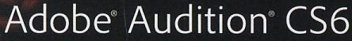  CLASSROOM IN A BOOK® | Chapter 10  The Multitrack Mixer View

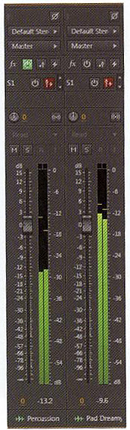 | The Mixer View is an alternate way to look at a multitrack project.  It is optimized for mixing rather than editing tracks.  Why use the Mixer View instead of the Multitrack Editor?  - the faders have extremely high resolution  - you can view the FX, Sends, EQ and Input/Output areas simultaneously  Are there any limits to the Mixer View?  - just one…you can’t edit clip properties  You can customize how much screen space Mixer View occupies.  - some parts of the Mixer can be hidden  - you can change the fader height to get more precision control  - channel scrolling is possible for complex projects  Channel faders are color coded as follows:  - standard tracks – gray  - buses – yellow  - master track output – blue

