The Console

Console - a complex network of switches, knobs & meters – also known as the board – a device for amplifying, routing & mixing audio signals

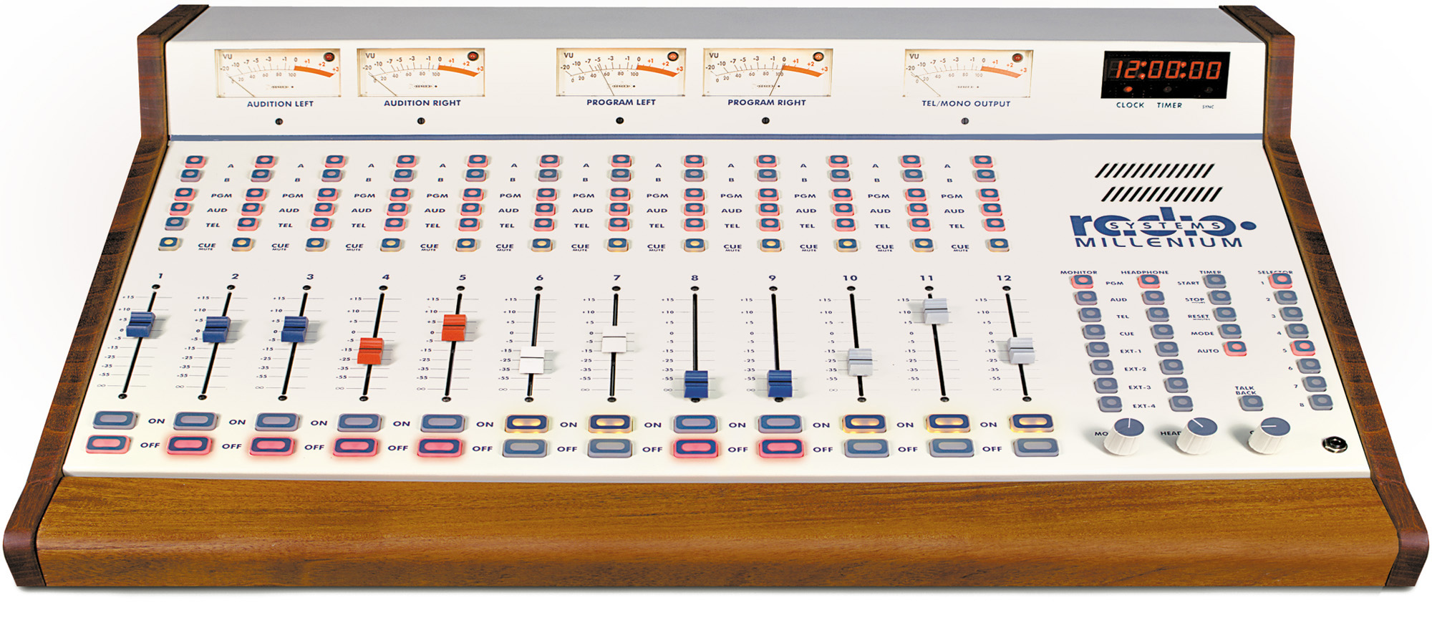

Amplification – the boosting of a signal to a usable level

The console gives you control over the volume of various signal sources.

Routing – consoles can send signals either over the air, into the audition mode, or into the cue speaker

The console route multiple signals at the same time (examples: microphone(s), CD players, turntables, cassette, Internet audio, etc.); how the volume of each signal is controlled is known as mixing.

Preamplifier – a device that boosts weak electrical signals to a more usable level

Potentiometer – also known as a fader or pot – a simple volume control; generally one pot controls one input source

Monitor – the studio loudspeakers to allow you to hear what is going through the console. Virtually all monitors are muted when any microphone is turned on in order to avoid feedback.

Amplifier – the device that amplifies, or boosts, a signal as it leaves the console

Segue – a transition from one audio element to the next; usually thought of in terms of the ending of one song and the overlapping beginning of the next

Most consoles have three destinations for audio signals:
- Program Channel – what is on the air
- Audition Channel – allows you to hear an audio source without putting it on the air; anything that can be put into the program channel can also be put into the audition channel
- Cue channel – allows you to preview a source of audio without interfering with the on-air signal; it is a small speaker built into the console

Master Fader – some consoles have these to allow one final control over multiple audio sources

Analog v. Digital consoles
Some consoles are analog, though the audio you mix in Adobe Audition or other software is digital. Analog source devices (turntables, CD players, cassette players) can be plugged into a digital console where the signals are converted from A → D. Think of a digital console as a complex computer workstation. The computer that contains Adobe Audition software is essentially a digital console.

Submixer – a miniature console that combines, or gangs, a group of inputs into one fader. The output of the submixer is then fed into the console.

