Recording and Playback Devices

CD burners, hard disk recording, flash drives and MiniDiscs have replaced both digital and analog audio tape in radio.

Magnetic tape can store both analog signals and digital information; optical recording stores digital information only.

Digital recording – starts with converting sound into data; it takes the two components of all audio signals (frequency & loudness) and converts them into mathematical representations (samples and quantization).

Sampling is the process of converting analog signals into numerical representations. Sampling takes a snapshot of the waveform and breaks it into tiny segments that can be expressed in binary numbers, or long sequences of 0s and 1s. One second of audio will be sampled 44,100 times. The greater amount of sampling that occurs, the greater the sonic resolution, or fidelity.

The value of each binary digit is called a bit.

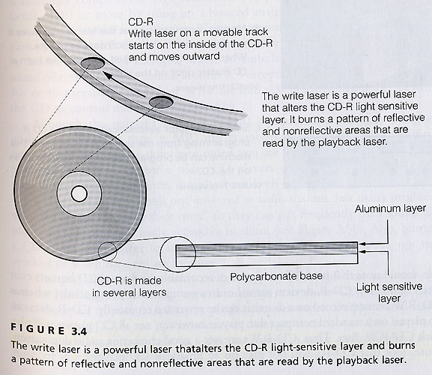

Magnetic tape – a strip of plastic material with a thin coating of iron oxide particles on one side. The particles form a magnetic flux when exposed to an electromagnetic field from the record head of the player.

The backing of the tape (where the coating is applied) is Mylar, an extremely tough substance that stretches before it breaks.

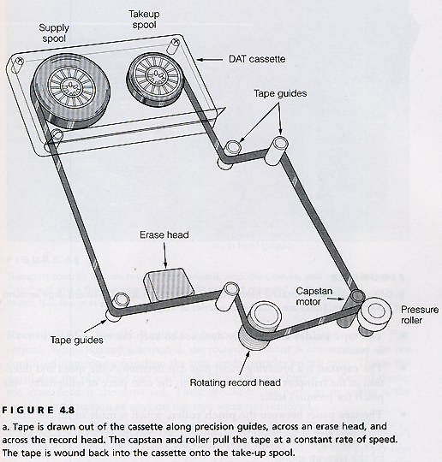

The record head is the electromagnet in the tape machine. In many machines the record/play head is one and the same. It produces magnetic pulses that arrange the iron particles in a particular order on a piece of magnetic tape. The playback head “reads” the pulses to play them back as tape moves from a supply spool to a take-up spool.

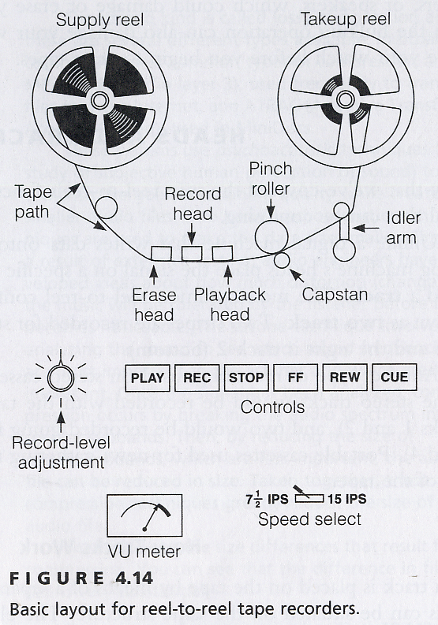

Parts of a tape machine (reel/cassette/or R-DAT):
- Tape guides – keep the tape in proper position
- Capstan – revolving metal post that drives the tape transport; this post comes into contact with the next item
- Pinch roller – hard rubber device that comes into contact with the capstan to pull the tape through the transport
- Idlers – provide constant tension for speed maintenance (more common on reel-to-reel machines than cassette machines)
- Heads – erase, record, playback

